Hidden layers = 10

Learning rate = 0.3

Momentum = 0.2

Epochs = 500

Validation threshold = 20

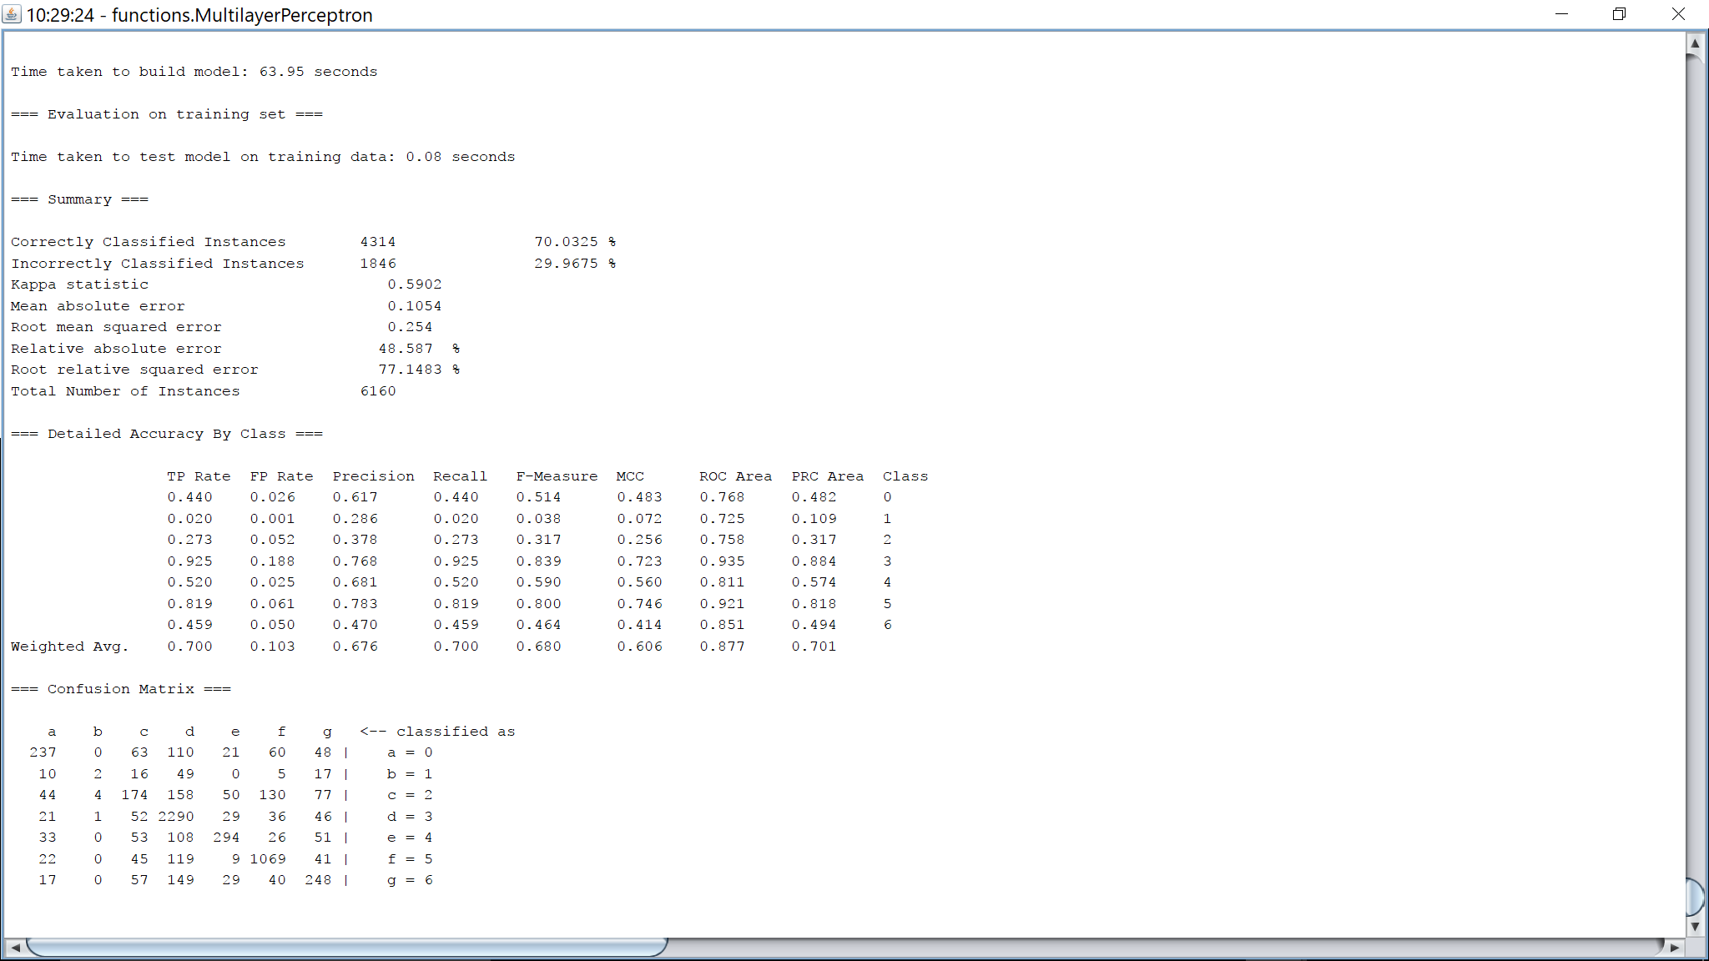

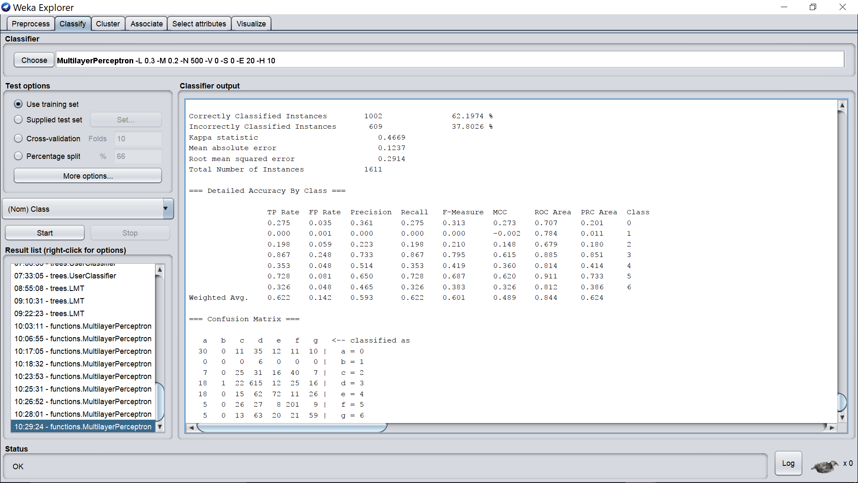

Hidden layers = 1

Learning rate = 0.3

Momentum = 0.2

Epochs = 500

Validation threshold = 20

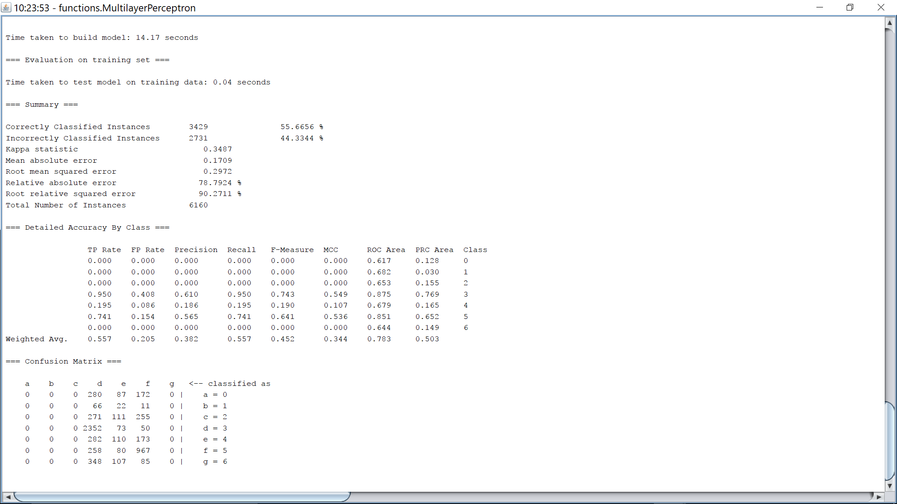

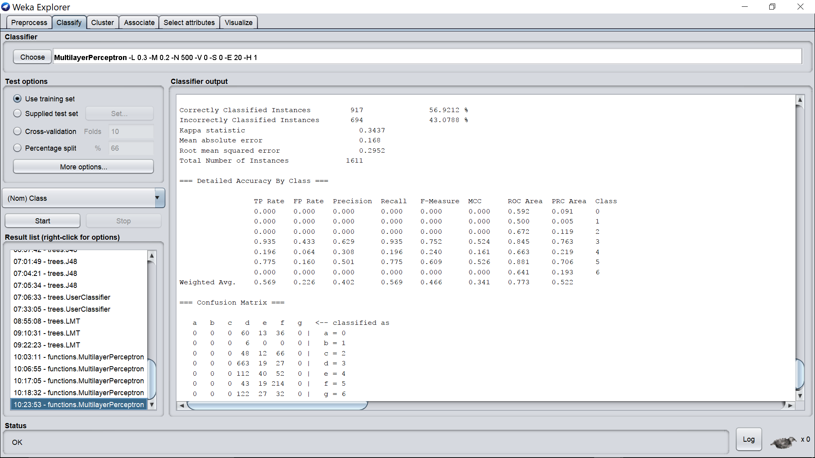

Hidden layers = 2

Learning rate = 0.3

Momentum = 0.2

Epochs = 500

Validation threshold = 20

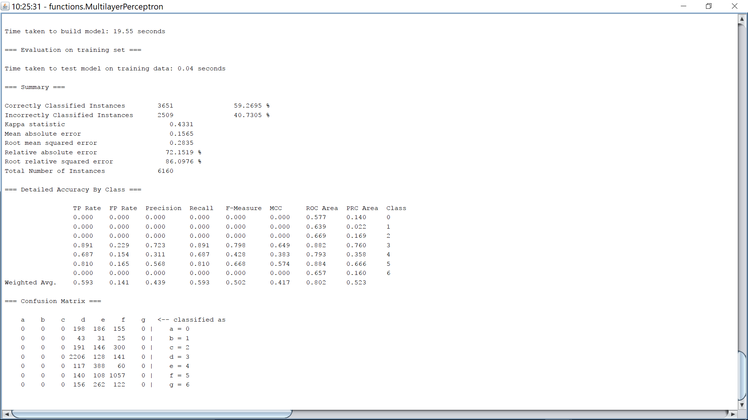

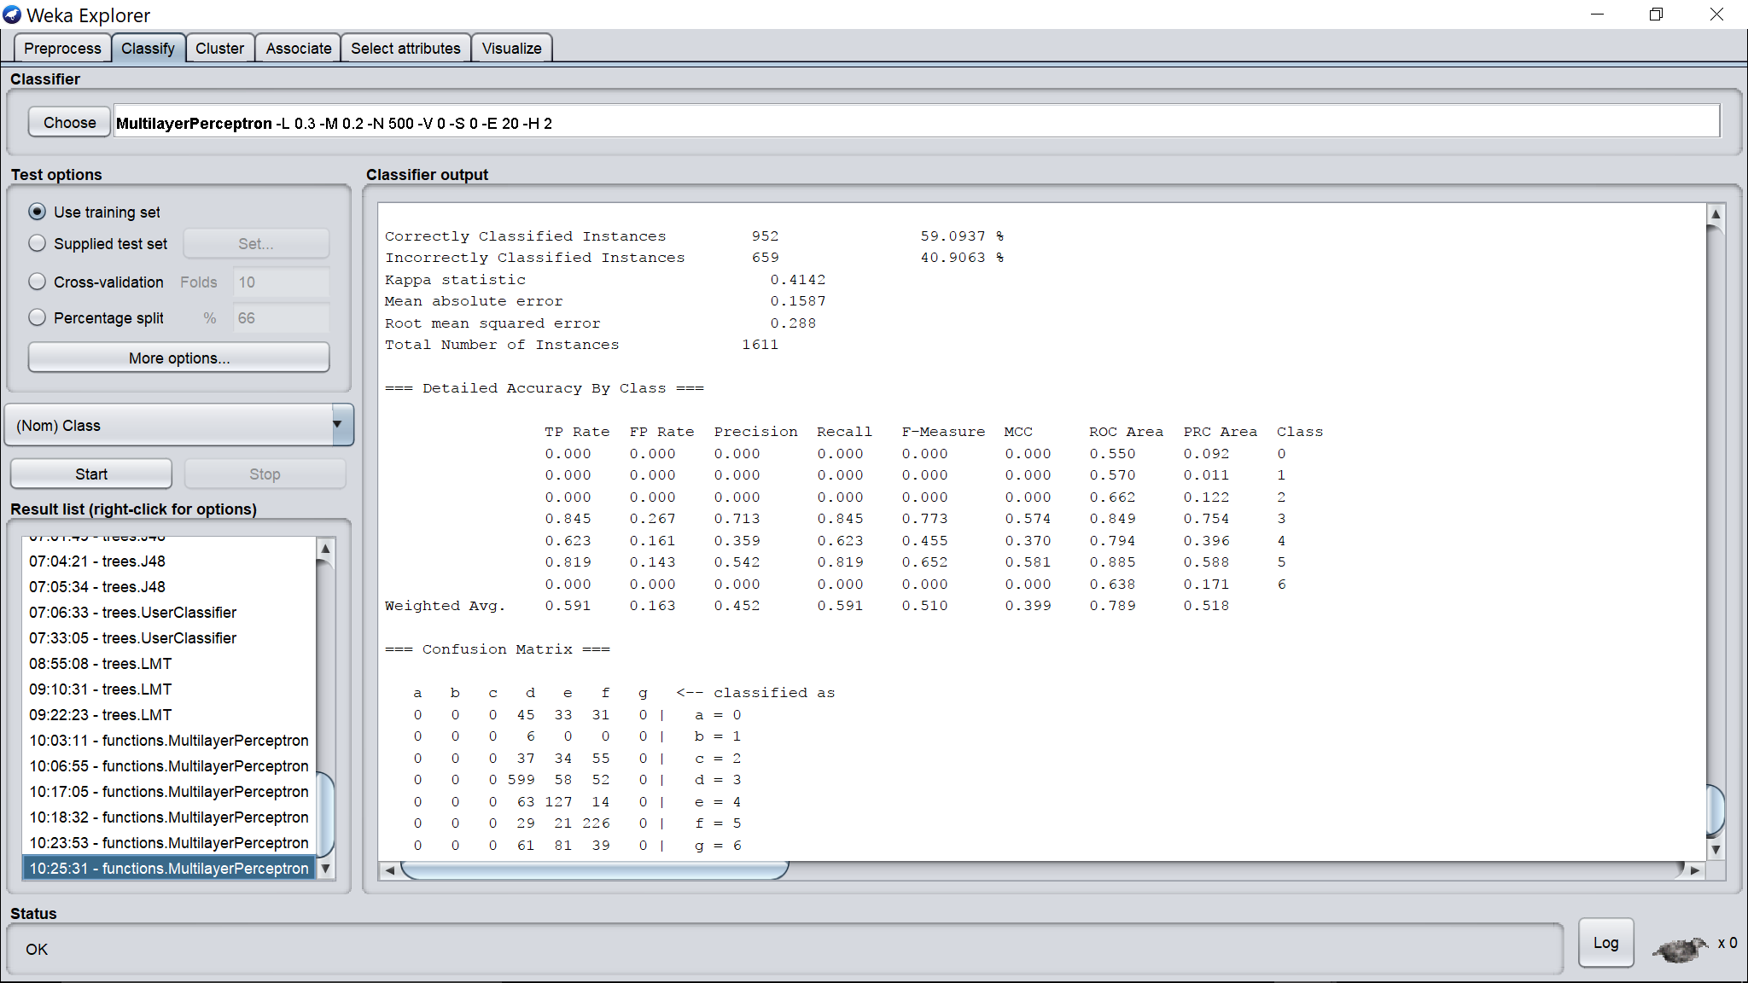

Hidden layers = 3

Learning rate = 0.3

Momentum = 0.2

Epochs = 500

Validation threshold = 20

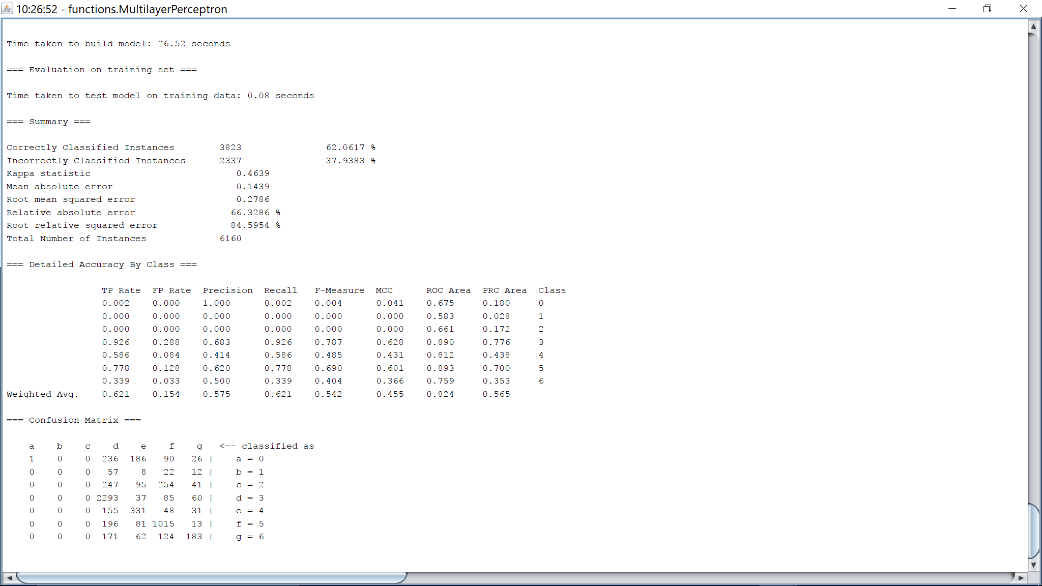

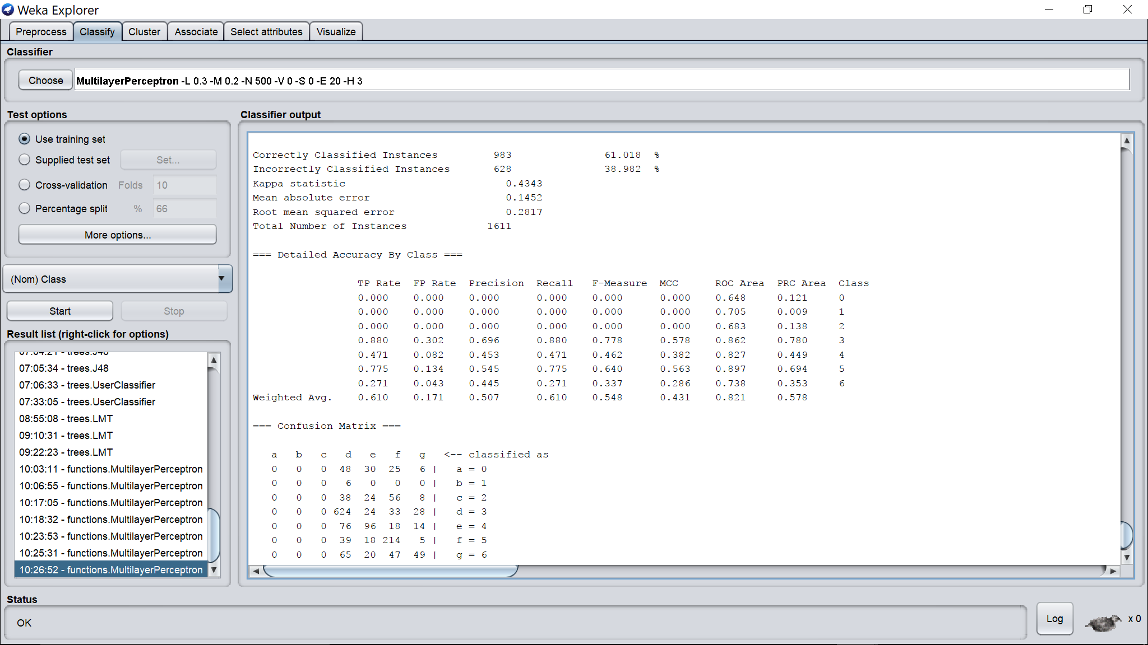

Hidden layers = 5

Learning rate = 0.3

Momentum = 0.2

Epochs = 500

Validation threshold = 20

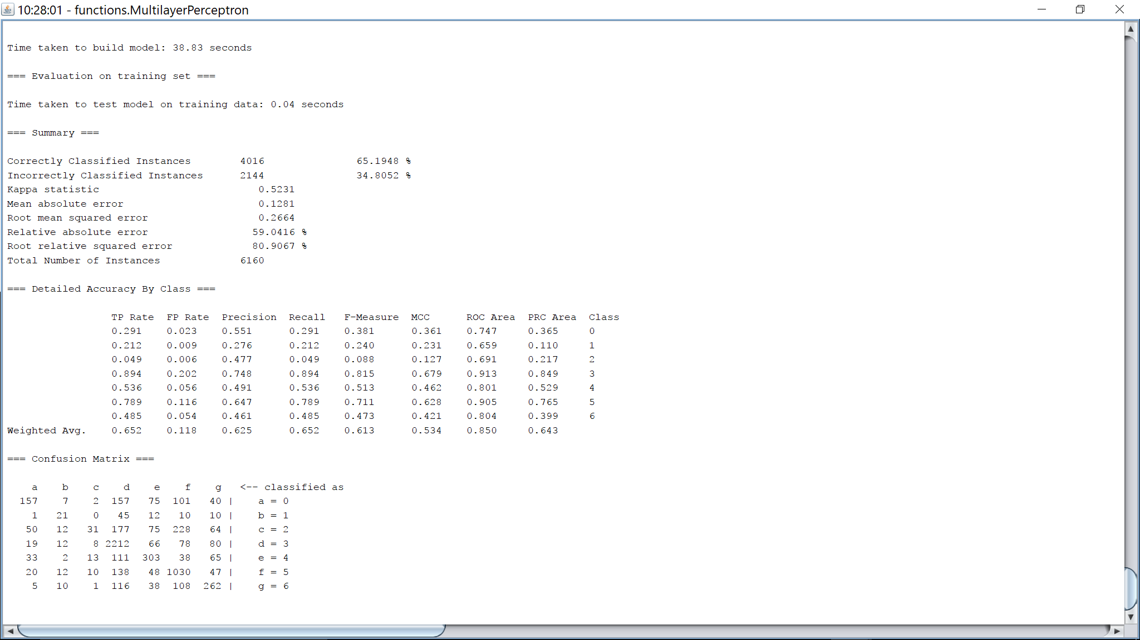

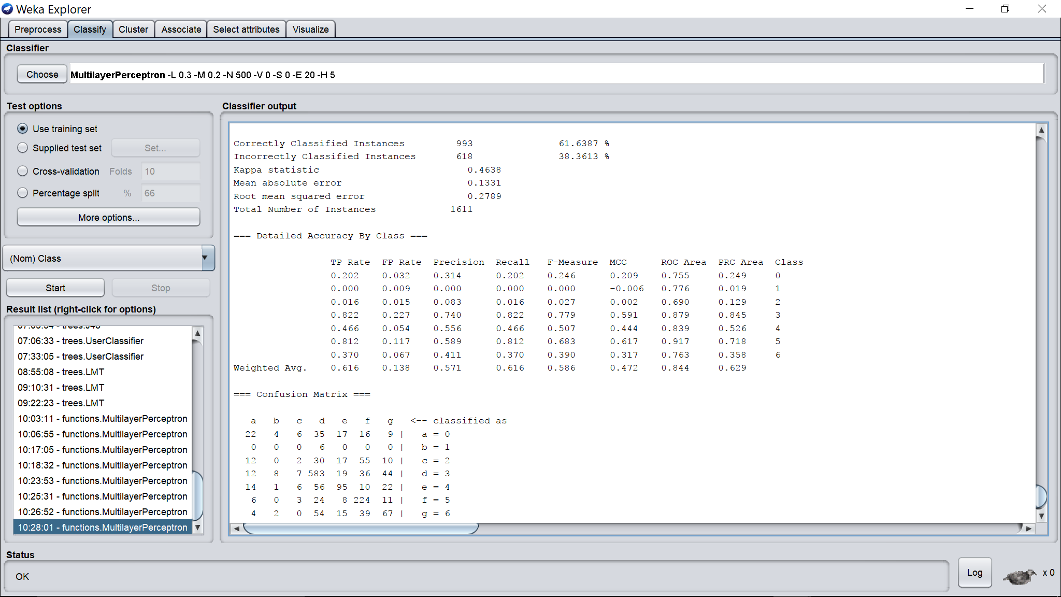

Hidden layers = 15

Learning rate = 0.3

Momentum = 0.2

Epochs = 500

Validation threshold = 20

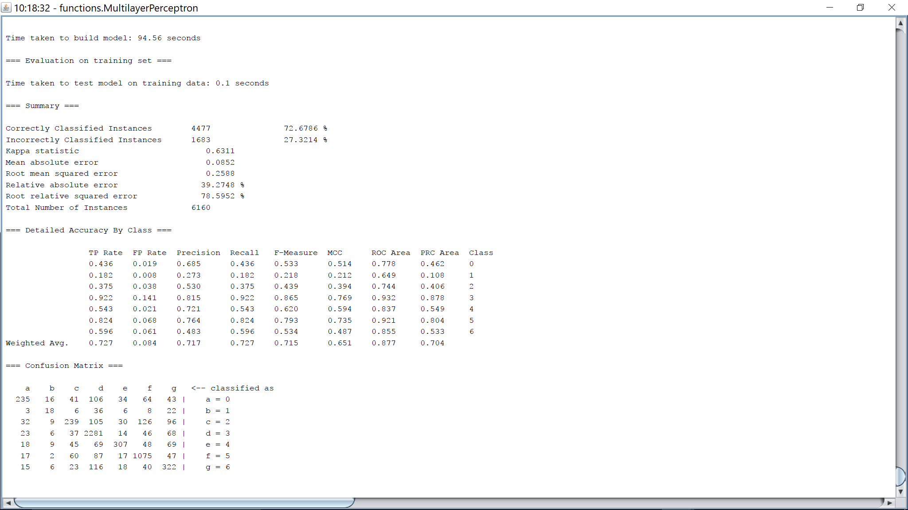

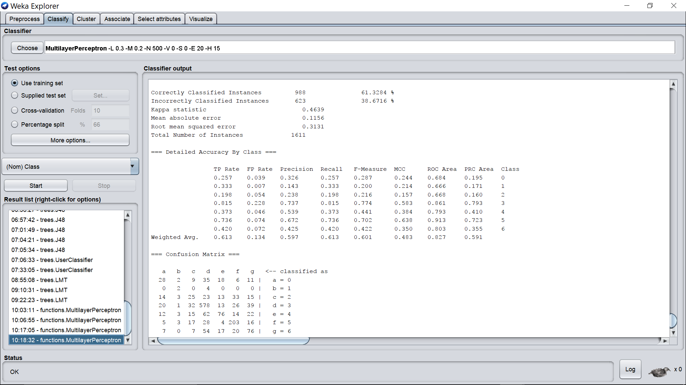

Hidden layers = 30

Learning rate = 0.3

Momentum = 0.2

Epochs = 500

Validation threshold = 20

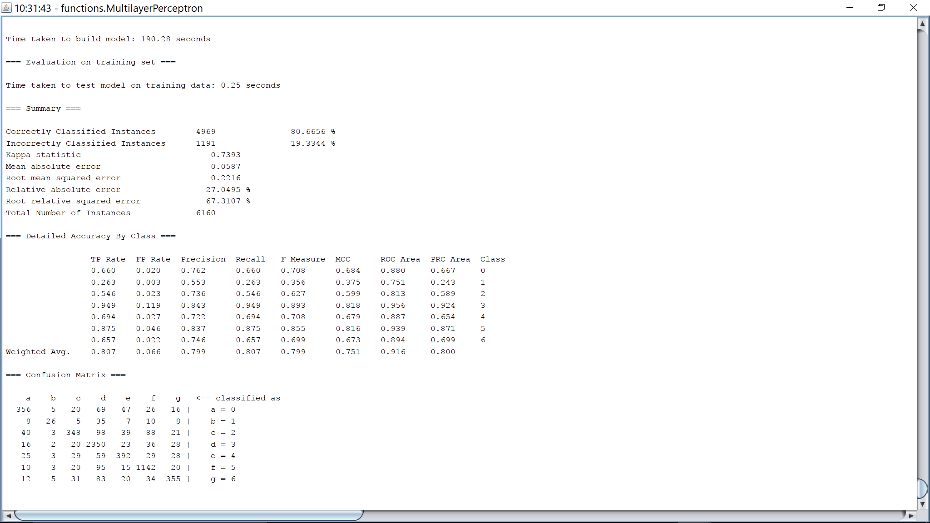

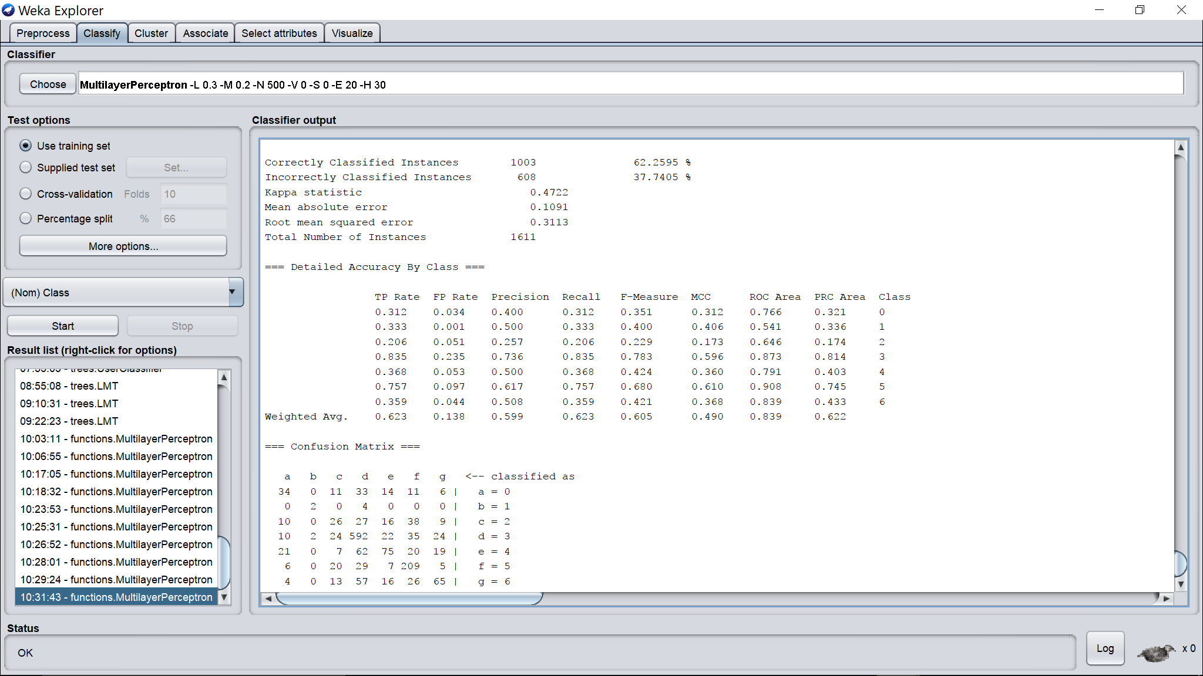

Hidden layers = 50

Learning rate = 0.3

Momentum = 0.2

Epochs = 500

Validation threshold = 20

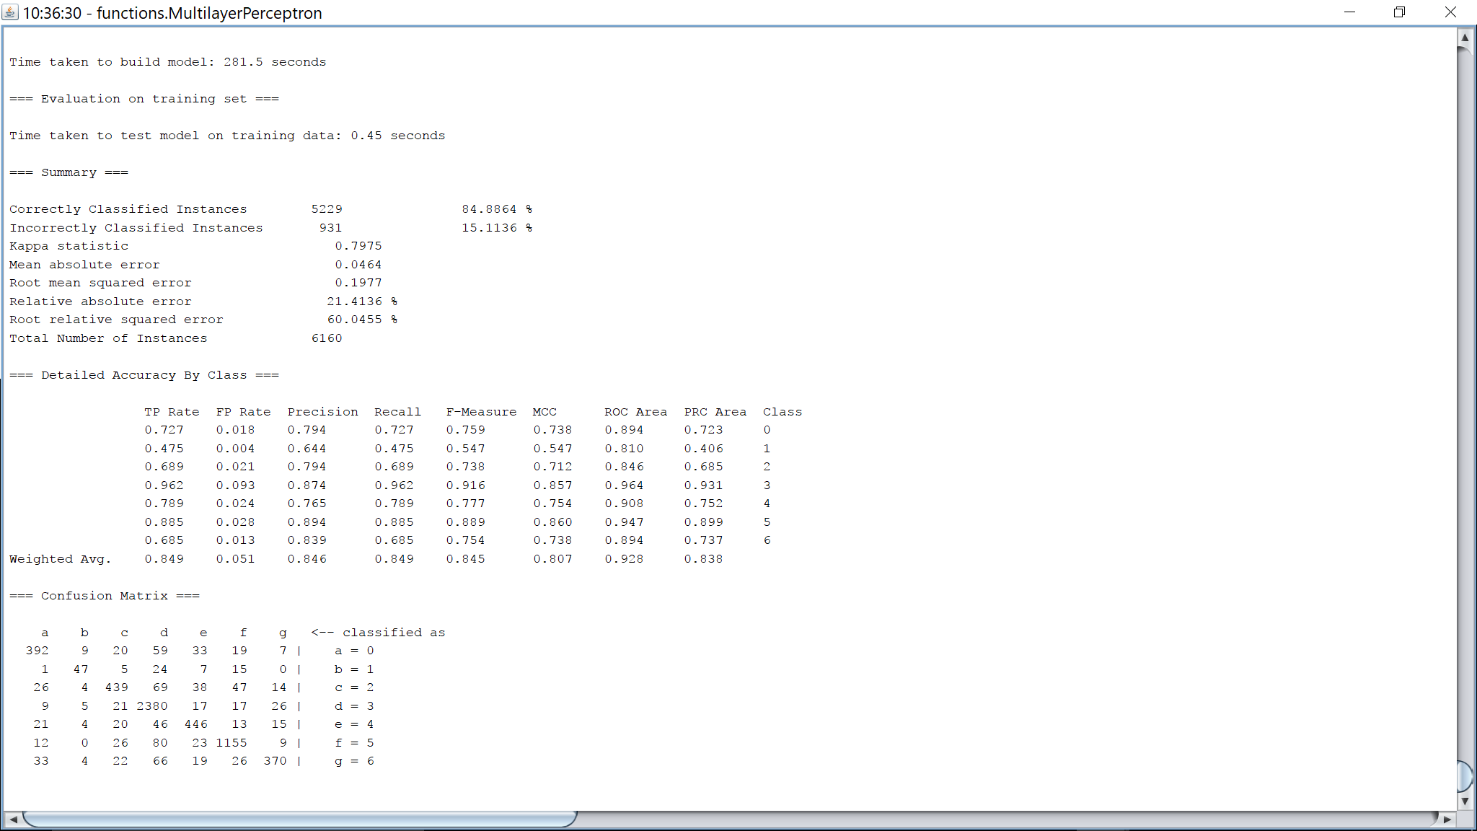

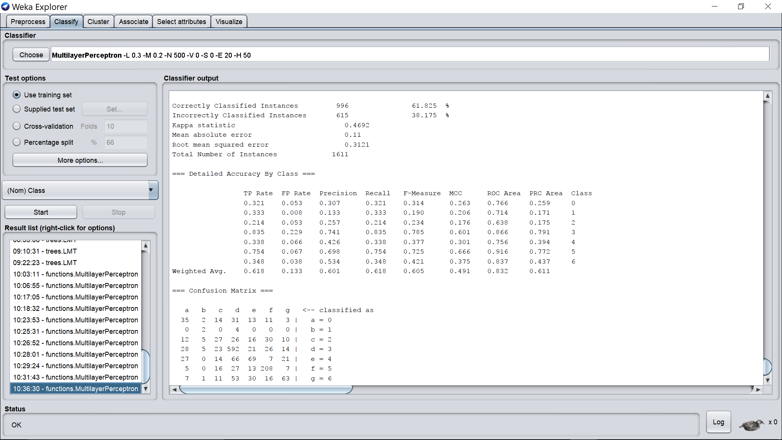

Hidden layers = 100

Learning rate = 0.3

Momentum = 0.2

Epochs = 500

Validation threshold = 20

